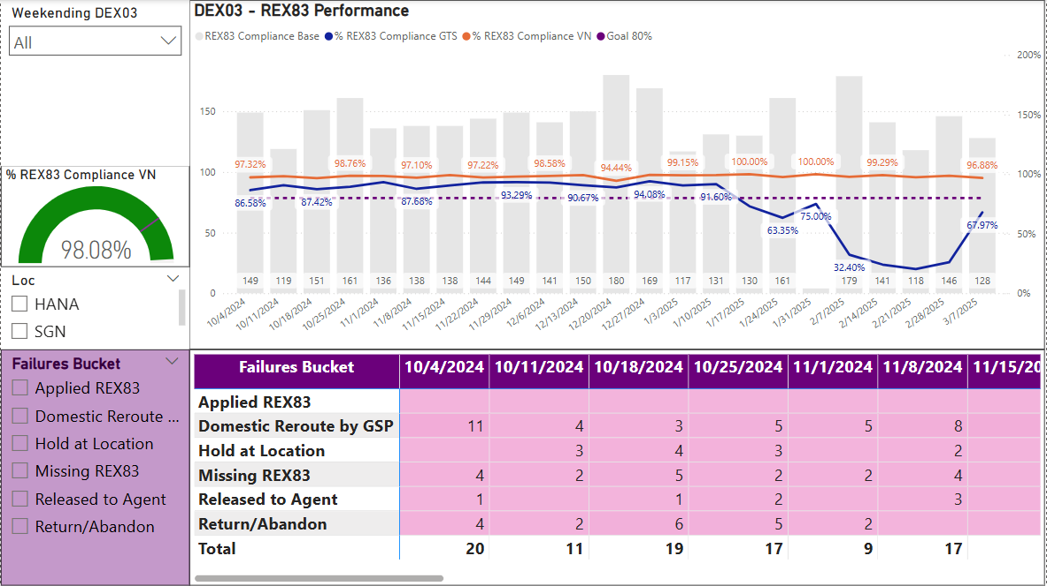

This dashboard help FedEx gain the overall visibility of the performance of customer’s payments after doing DEX03 scan representing for wrong delivery address. After spotting the “Missing REX83” (did not charge payment for changing delivery address) through the Dashboard, we report to the vendor to implement REX83 and charge the right amount of changing address payment from customer, avoiding the revenue loss for FedEX.

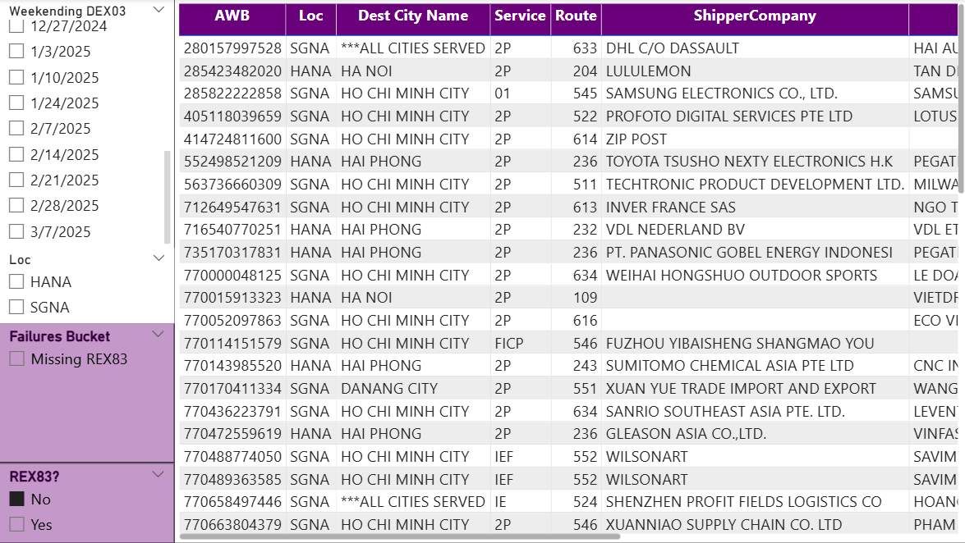

The next page is the AWB number that are “Missing REX83”.